

Payment

Requirement Document

**Version 1.0**

|  |  |
| --- | --- |
| ***Corporate Office & Development Center*** | ***Offshore Development Center*** |
| *5 Concourse Parkway*  *Suite 3200, Atlanta, Georgia 30328*  *Tel 678.281.2014*  *Fax: 678.281.2019* | *Plot # 122 & 123, N.S.E.Z, Phase -2*  *NOIDA, UP 201 305*  *India*  *Tel: 91.11.91.2510483* |

|  |  |  |  |  |
| --- | --- | --- | --- | --- |
| **Author** | | | | |
| **Name** | **Role** | **Date of Preparation** | **Signature** | |
| Evelyn Yap | Project manager | 19-Jan-2015 | Evelyn | |
| **Reviewer(s)** | | | | |
| **Name** | **Role** | **Date of Review** | **Signature** | |
| Pravesh Kumar | Manager Projects |  |  | |
|  |  |  |  | |
| **Approver** | | | | |
| **Name** | **Role** | **Date of Approval** | **Signature** | |
| ChengChoon Yip | VP Ebix Exchange  Asia |  |  | |
| **Document Path** | **Version Number** | **Date of Release** | | |
|  | 1.00 | 19-Jan-2015 | | |
| **Revision History** | | | | |
| **Version Number** | **Date of Release** | **Section/ Page # Changed** | | **Details of Changes** |
| 1.00 | 19-Jan-2015 | All | | Document created |

|  |  |  |
| --- | --- | --- |
| **References** | | |
| **Document** | **Date Received** | **Author** |
|  |  |  |

Contents

2. Overview 4

**a.** Module 4

**b.** Development Type 4

3. Payment Processing 4

3.1 3.1 Under Claims Adjustment: 5

3.2 Under Claims Payment Processing: 5

4. Screenshots 7

4.1 Payment Tab 7

4.2 TPPD Payment Request 8

4.3 TPPD Payment Approval 9

4.4 TPBI Payment Request 10

4.5 OD Payment Request 11

4.6 OD Payment Approval 12

5. Payment Request With Field List 13

6. Payment Form With Field List 16

7. NEL Payment Form With Field List 19

8. Payment Summary With Field List 22

9. Debit Note Requisition Form 24

10. Cheque Cancellation Or Reissue Memo With Field List 26

11. Rule 27

12. Implementation 27

12.1 Current Implementation 27

12.2 Targeted Implementation 28

13. Change Required 28

# Overview

|  |  |  |  |
| --- | --- | --- | --- |
| ☒ | New | ☐ | Change Request |

* 1. Module

|  |  |  |  |  |  |
| --- | --- | --- | --- | --- | --- |
| ☐ | Diary | ☐ | System Admin Module | ☐ | Claim Registration |
| ☒ | Claim Payment | ☐ | Claim Recovery | ☐ | Claim Enquiry |
| ☐ | Upload | ☐ | Reports |  |  |

* 1. Development Type

|  |  |  |  |  |  |
| --- | --- | --- | --- | --- | --- |
| ☒ | Functionality | ☒ | Integration | ☐ | Rule |
| ☐ | Report | ☒ | Field | ☒ | Screen |

# Payment Processing

## 3.1 Under Claims Adjustment:

* Summary of Payment Details will be read-only. User has to go to Claims Payment Processing Menu to create Payment Approval Request

## Under Claims Payment Processing:

* Change search fields: Policy No. to Claim No. / Insured Name to Claimant Name / Remove Organization Country or rename to Claim Type and selection = Own Damage / Property Damage / Bodily Injury. Include Search Field for Claim Type: <<Dropdown – Own Damage / Property Damage / Bodily Injury >>
* Search Results:

|  |  |  |  |  |  |  |
| --- | --- | --- | --- | --- | --- | --- |
| S/No. | Claim No. | Claimant Name | Claim Type | Accident Date | Vehicle No. | Action |
| 1 |  |  |  |  |  | << Select >> |
|  |  |  |  |  |  |  |

Note: Upon clicking on Select, System will bring user to Payment Processing Screen (similar to screen layout for Claim Registration, all tabs are blocked out except for Payment Tab)

* Payment Tab Grid:

|  |  |  |  |  |  |  |  |  |
| --- | --- | --- | --- | --- | --- | --- | --- | --- |
| +/- | Claim Type / No. | Claimant Name | Claimant Name | Amount Paid | Payee | Approved Date | Status | Action |
| + | OD |  |  |  |  |  |  |  |
| 🡪 | OD-001 |  |  |  |  |  | << Approved / Rejected >> | << Select >> |
| + | PD |  |  |  |  |  |  |  |
| 🡪 | PD-001 |  |  |  |  |  | << Approved / Rejected >> | << Select >> |
| 🡪 | PD-002 |  |  |  |  |  | << Approved / Rejected >> | << Select >> |
| + | BI |  |  |  |  |  |  |  |
| 🡪 | BI-001 |  |  |  |  |  | << Approved / Rejected >> | << Select >> |
| 🡪 | BI-002 |  |  |  |  |  | << Approved / Rejected >> | << Select >> |

* When User clicks on Select, the Relevant Payment Approval Request Screen will appear:

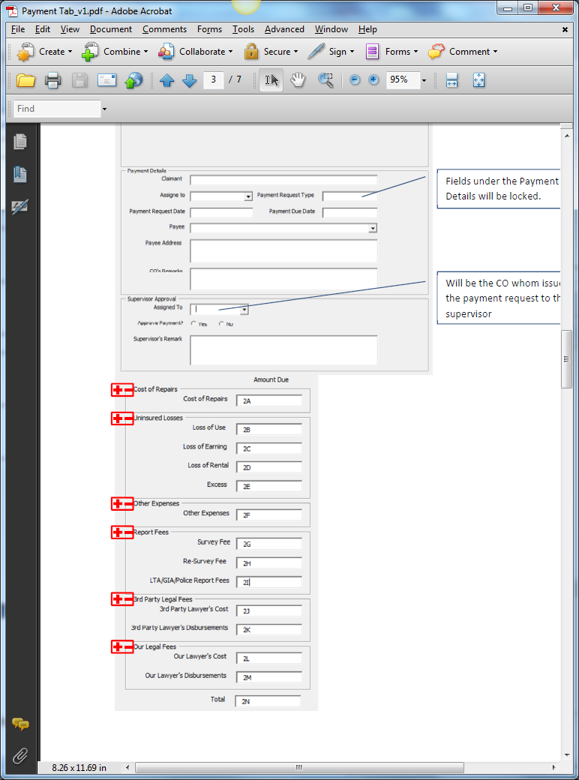

Relevant Fields from Mandate Request Screen.

Include Approved Mandate Column. Read Only. Amount Due is less than or equal to this value. Editable by CO and Supervisor

Address as Address1, Address2, Address3, Postal Code

Populate Created Service Providers

Validate with Supervisor’s FAL

* Supervisor Approval Section to have Access Rights.
* Validation: Mandate must be approved and there must be Reserve created before User can create any Payment Approval Request
* Validation: If Initial Reserve = 0, no Payment is allowed. If Mandate Status is Approved, show Outstanding Amount and Initial Reserve has values, Payment is allowed. If Mandate Status is Pending, show Pending Status. If Mandate Status is rejected, show status as 0. If Mandate is not created, show status as 0.
* Under Payment Due Date: System is to keep track of this date and when it is expired, system will highlight this entry as red in the Diary Listing. To highlight entry as green 2 days before Expiry Date.

# Screenshots

## Payment Tab

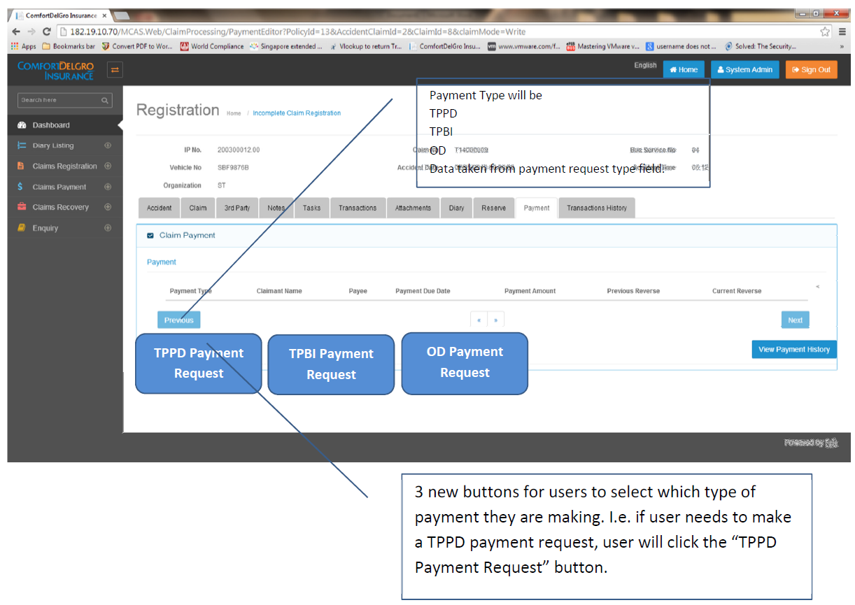

## TPPD Payment Request

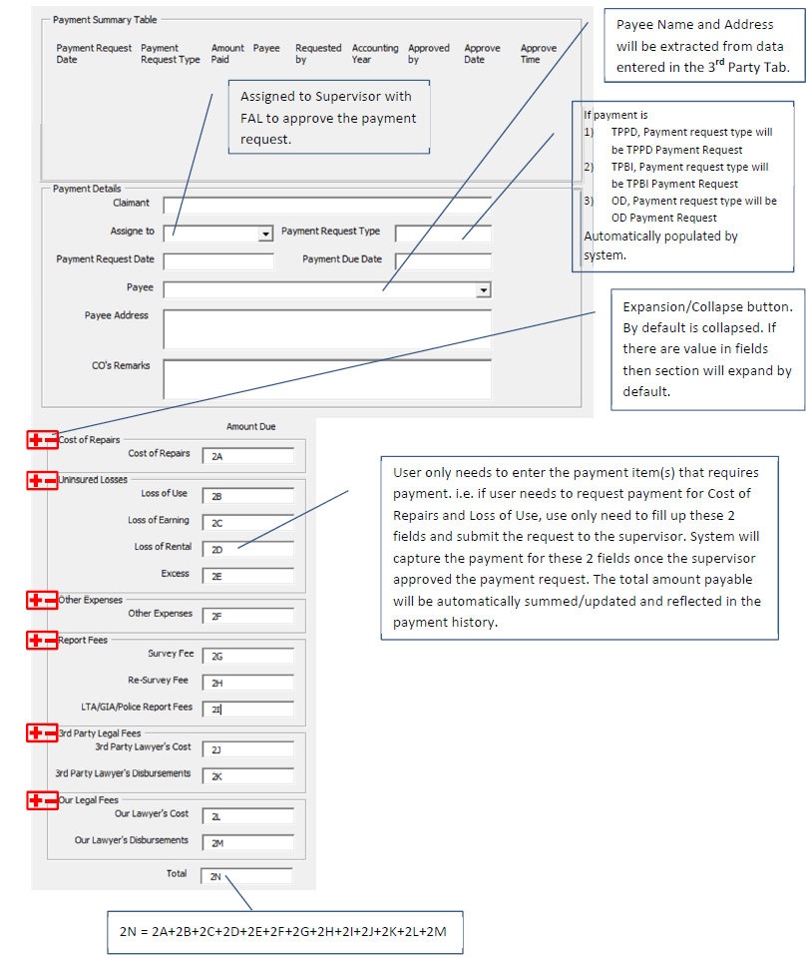

## TPPD Payment Approval

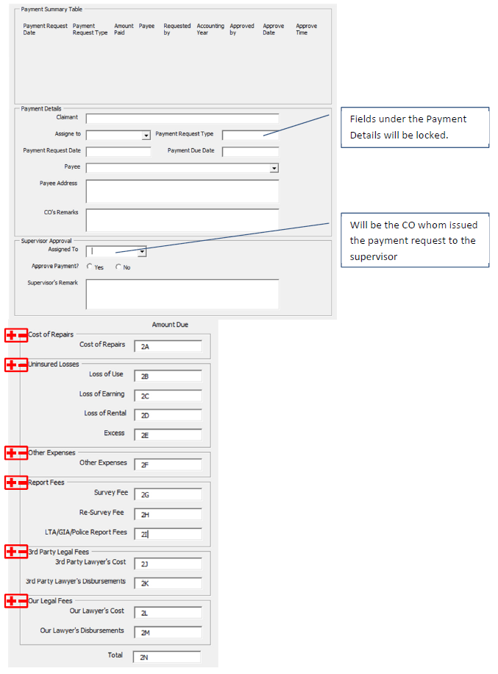

## TPBI Payment Request

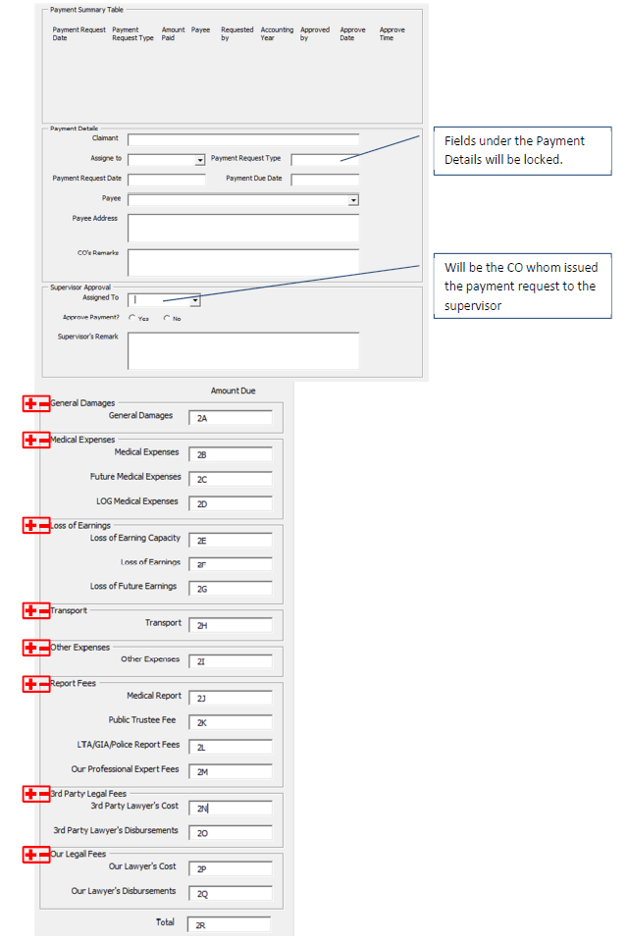

## OD Payment Request

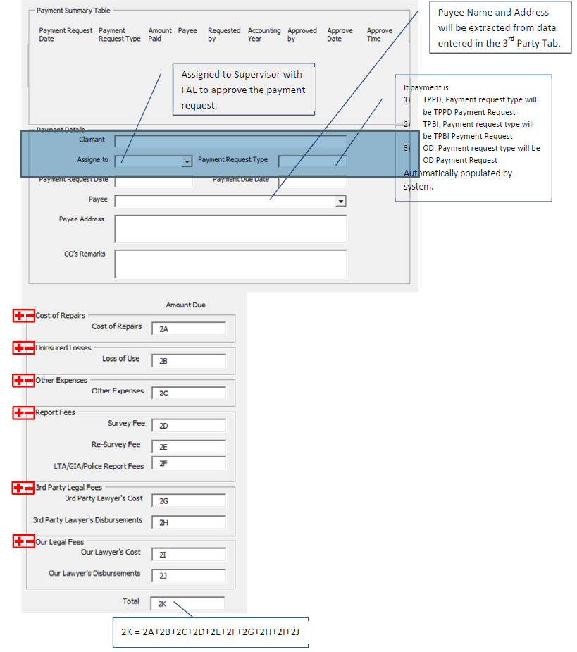

## OD Payment Approval

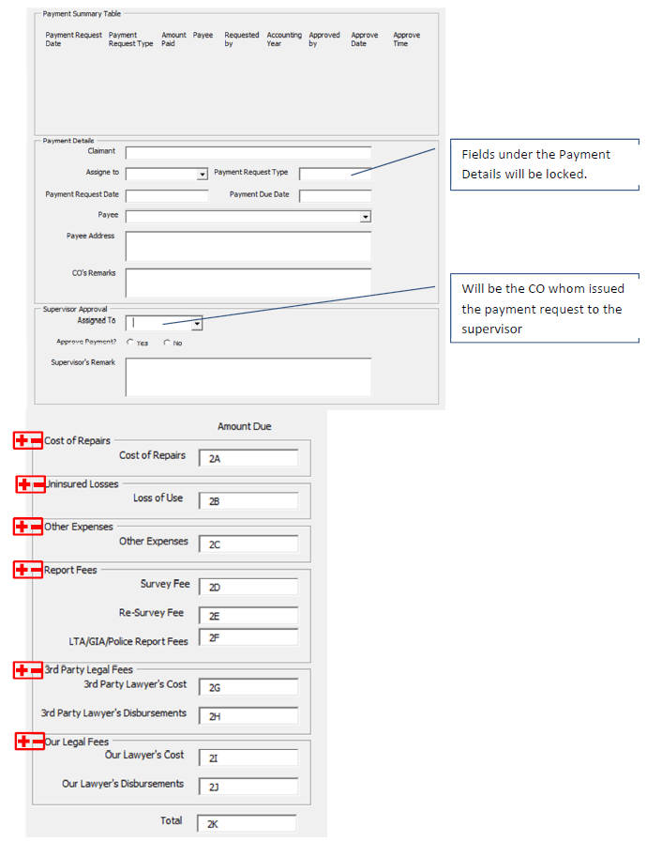

# Payment Request With Field List

|  |  |  |  |  |  |  |
| --- | --- | --- | --- | --- | --- | --- |
| **Form name** | Payment Request | | |  |  |  |
| Description |  | | |  | | |
| s.no. | Field number as per screen | Field names | screen Name | screen field name | EBIX Remarks | CDGI Remarks |
| 1 | F-1 | Field not confirm | User Admin | User | Pre-fixed or User ID? |  |
| 2 | F-2 | Label " payment request " | Unknown | Unknown | To Be Pre-fixed? |  |
| 3 | F-3 | please refer attached screen shot | Insurance Master | Insurer |  |  |
| 4 | F-4 | please refer attached screen shot | Payment | Local Currency |  |  |
| 5 | F-5 | please refer attached screen shot | Unknown | Unknown | Insurer's Address? |  |
| 6 | F-6 | please refer attached screen shot | Unknown | Unknown | Insurer's Address? |  |
| 7 | F-7 | please refer attached screen shot | Unknown | Unknown |  |  |
| 8 | F-8 | please refer attached screen shot | Unknown | Unknown |  |  |
| 9 | F-9 | please refer attached screen shot | Unknown | Unknown |  |  |
| 10 | F-10 | please refer attached screen shot | Unknown | Unknown | Is This from Finance Tab? |  |
| 11 | F-11 | please refer attached screen shot | Unknown | Unknown | Is This from Finance Tab? |  |
| 12 | F-12 | please refer attached screen shot | Unknown | Unknown | Is This from Finance Tab? |  |
| 13 | F-13 | please refer attached screen shot | Unknown | Unknown | Is This from Finance Tab? |  |
| 14 | F-14 | please refer attached screen shot | Unknown | Unknown | Is This from Finance Tab? |  |
| 15 | F-15 | please refer attached screen shot | Unknown | Unknown | Is This from Finance Tab? |  |
| 16 | F-16 | please refer attached screen shot | Unknown | Unknown | Is This from Finance Tab? |  |
| 17 | F-17 | please refer attached screen shot | Unknown | Unknown | Is This from Finance Tab? |  |
| 18 | F-18 | please refer attached screen shot | Unknown | Unknown | Is This from Finance Tab? |  |
| 19 | F-19 | please refer attached screen shot | Unknown | Unknown | Is This from Finance Tab? |  |
| 20 | F-20 | please refer attached screen shot | Unknown | Unknown | Is This from Finance Tab? |  |
| 21 | F-21 | please refer attached screen shot | User Admin | User | Pre-fixed? |  |
| 22 | F-22 | please refer attached screen shot | User Admin | Group / Department | Pre-fixed? |  |
| 23 | F-23 | please refer attached screen shot |  |  | Pre-fixed? |  |
| 24 | F-24 | please refer attached screen shot | User Admin | User | Pre-fixed? |  |
| 25 | F-25 | please refer attached screen shot | User Admin | Group / Department | Pre-fixed? |  |
| 26 | F-26 | please refer attached screen shot | Unknown | Unknown |  |  |
| 27 | F-27 | please refer attached screen shot | Payment | Local Currency | Or From Finance Tab? |  |
| 28 | F-28 | please refer attached screen shot | Unknown | Unknown |  |  |
| 29 | F-29 | please refer attached screen shot | Unknown | Unknown |  |  |
| 30 | F-30 | please refer attached screen shot | User Admin | User | Pre-fixed or based on User ID? |  |
| 31 | F-31 | please refer attached screen shot | Claim | Preview Documents | Date that Document is generated? |  |

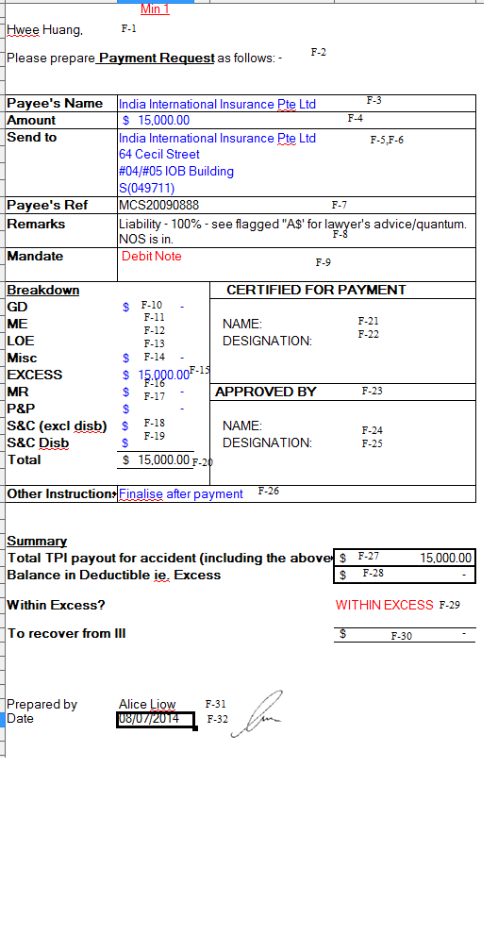

# Payment Form With Field List

|  |  |  |  |  |  |  |
| --- | --- | --- | --- | --- | --- | --- |
| **Form name** | Payment Form | | |  |  |  |
| Description |  | | |  | | |
| s.no. | Field number as per screen | Field names | screen Name | screen field name | EBIX Remarks | CDGI Remarks |
| 1 | F-1 | please refer attached screen shot | Accident | IP No |  |  |
| 2 | F-2 | please refer attached screen shot | User Admin | User | Blank or Pre-fixed or based on User ID? |  |
| 3 | F-3 | please refer attached screen shot | Claims | Preview Documents | Date that Document is generated? |  |
| 4 | F-4 | please refer attached screen shot | User Admin | Group / Department | Blank or Pre-fixed or based on User ID? |  |
| 5 | F-5 | please refer attached screen shot | User Admin | User | Blank or Pre-fixed or based on User ID? |  |
| 6 | F-6 | please refer attached screen shot | User Admin | Group / Department | Blank or Pre-fixed or based on User ID? |  |
| 7 | F-7 | 1st party involved in accident | Accident | Vehicle No | Claimant Name / Payee Name / Bus Service No. / Vehicle No? |  |
|  | F-29 | 2nd party involved in accident | Unknown | Unknown | Do we need another Claimant Name / Payee Name / Bus Service No. / Vehicle No? |  |
| 8 | F-8 | road name | Accident | Road Name |  |  |
| 9 | F-9 | accident date | Accident | Accident Date |  |  |
| 10 | F-10 | please refer attached screen shot | Payment | Local Currency |  |  |
| 11 | F-11 | please refer attached screen shot |  |  | Is this from the Finance Tab? |  |
| 12 | F-12 | please refer attached screen shot | Payment | Payee | Unknown / Claimant Name / Payee Name? |  |
| 13 | F-13 | please refer attached screen shot | Unknown | Unknown | Is this from the Finance Tab? |  |
| 14 | F-14 | please refer attached screen shot | Unknown | Unknown | Is this from the Finance Tab? |  |
| 15 | F-15 | please refer attached screen shot | Unknown | Unknown | Is this from the Finance Tab? |  |
| 16 | F-16 | please refer attached screen shot | Unknown | Unknown | Is this from the Finance Tab? |  |
| 17 | F-17 | please refer attached screen shot | Unknown | Unknown | Is this from the Finance Tab? |  |
| 18 | F-18 | please refer attached screen shot | Unknown | Unknown | Is this from the Finance Tab? |  |
| 19 | F-19 | please refer attached screen shot | Unknown | Unknown | Is this from the Finance Tab? |  |
| 20 | F-20 | please refer attached screen shot | Unknown | Unknown | Is this from the Finance Tab? |  |
| 21 | F-21 | please refer attached screen shot | Unknown | Unknown | Is this from the Finance Tab? |  |
| 22 | F-22 | please refer attached screen shot | Unknown | Unknown | Is this from the Finance Tab? |  |
| 23 | F-23 | please refer attached screen shot | Unknown | Unknown | Is this from the Finance Tab? |  |
| 24 | F-24 | please refer attached screen shot | Unknown | Unknown | Is this from the Finance Tab? |  |
| 25 | F-25 | please refer attached screen shot | Unknown | Unknown | Is this from the Finance Tab? |  |
| 26 | F-26 | please refer attached screen shot | Unknown | Unknown | Is this from the Finance Tab? |  |
| 27 | F-27 | please refer attached screen shot | Unknown | Unknown | Is this from the Finance Tab? |  |
| 28 | F-28 | please refer attached screen shot | Unknown | Unknown | Is this from the Finance Tab? |  |

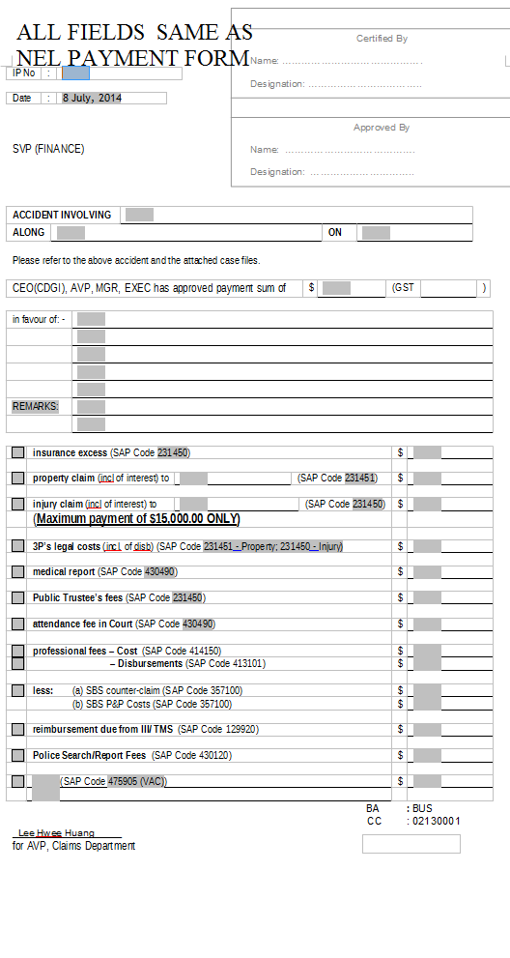

# NEL Payment Form With Field List

|  |  |  |  |  |  |  |
| --- | --- | --- | --- | --- | --- | --- |
| **Form name** | NEL Payment form | | |  |  |  |
| Description |  | | |  | | |
| s.no. | Field number as per screen | Field names | screen Name | screen field name | EBIX Remarks | CDGI Remarks |
| 1 | F-1 | please refer attached screen shot | Accident | IP No |  |  |
| 2 | F-2 | please refer attached screen shot | User Admin | User | Blank or Pre-fixed or based on User ID? |  |
| 3 | F-3 | please refer attached screen shot | Claims | Preview Documents | Date that Document is generated? |  |
| 4 | F-4 | please refer attached screen shot | User Admin | Group / Department | Blank or Pre-fixed or based on User ID? |  |
| 5 | F-5 | please refer attached screen shot | User Admin | User | Blank or Pre-fixed or based on User ID? |  |
| 6 | F-6 | please refer attached screen shot | User Admin | Group / Department | Blank or Pre-fixed or based on User ID? |  |
| 7 | F-7 | 1st party involved in accident | Accident | Vehicle No | Claimant Name / Payee Name / Bus Service No. / Vehicle No? |  |
|  | F-29 | 2nd party involved in accident | Unknown | Unknown | Do we need another Claimant Name / Payee Name / Bus Service No. / Vehicle No? |  |
| 8 | F-8 | road name | Accident | Road Name |  |  |
| 9 | F-9 | accident date | Accident | Accident Date |  |  |
| 10 | F-10 | please refer attached screen shot | Payment | Local Currency |  |  |
| 11 | F-11 | please refer attached screen shot |  |  | Is this from the Finance Tab? |  |
| 12 | F-12 | please refer attached screen shot | Payment | Payee | Unknown / Claimant Name / Payee Name? |  |
| 13 | F-13 | please refer attached screen shot | Unknown | Unknown | Is this from the Finance Tab? |  |
| 14 | F-14 | please refer attached screen shot | Unknown | Unknown | Is this from the Finance Tab? |  |
| 15 | F-15 | please refer attached screen shot | Unknown | Unknown | Is this from the Finance Tab? |  |
| 16 | F-16 | please refer attached screen shot | Unknown | Unknown | Is this from the Finance Tab? |  |
| 17 | F-17 | please refer attached screen shot | Unknown | Unknown | Is this from the Finance Tab? |  |
| 18 | F-18 | please refer attached screen shot | Unknown | Unknown | Is this from the Finance Tab? |  |
| 19 | F-19 | please refer attached screen shot | Unknown | Unknown | Is this from the Finance Tab? |  |
| 20 | F-20 | please refer attached screen shot | Unknown | Unknown | Is this from the Finance Tab? |  |
| 21 | F-21 | please refer attached screen shot | Unknown | Unknown | Is this from the Finance Tab? |  |
| 22 | F-22 | please refer attached screen shot | Unknown | Unknown | Is this from the Finance Tab? |  |
| 23 | F-23 | please refer attached screen shot | Unknown | Unknown | Is this from the Finance Tab? |  |
| 24 | F-24 | please refer attached screen shot | Unknown | Unknown | Is this from the Finance Tab? |  |
| 25 | F-25 | please refer attached screen shot | Unknown | Unknown | Is this from the Finance Tab? |  |
| 26 | F-26 | please refer attached screen shot | Unknown | Unknown | Is this from the Finance Tab? |  |
| 27 | F-27 | please refer attached screen shot | Unknown | Unknown | Is this from the Finance Tab? |  |
| 28 | F-28 | please refer attached screen shot | Unknown | Unknown | Is this from the Finance Tab? |  |

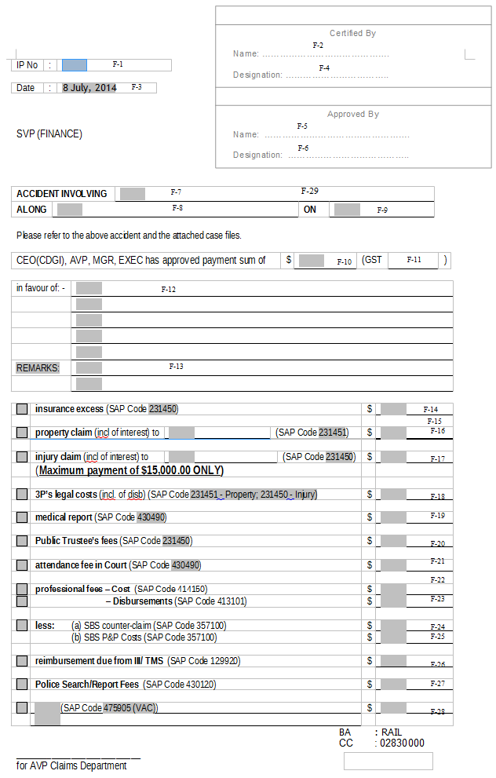

# Payment Summary With Field List

|  |  |  |  |  |  |  |
| --- | --- | --- | --- | --- | --- | --- |
| **Form name** | Payment summary | | |  |  |  |
| Description |  | | |  | | |
| s.no. | Field number as per screen | Field names | screen Name | screen field name | EBIX Remarks | CDGI Remarks |
| 1 | F-1 | claim type | 3rd Party | Other Party Type |  |  |
| 2 | F-2 | IP no. | Accident | IP No. |  |  |
| 3 | F-3 | File no. | Unknown | Unknown | Is This From Finance Tab? |  |
| 4 | F-4 | C/F | Unknown | Unknown | Is This From Finance Tab? |  |
| 5 | F-5 | please refer attached screen shot | Payment | Claimant Name |  |  |
| 6 | F-6 | please refer attached screen shot | Payment | Payee's Name |  |  |
| 7 | F-7 | please refer attached screen shot | Reserve | Previous Reserve |  |  |
| 8 | F-8 | please refer attached screen shot | Unknown | Unknown |  |  |
| 9 | F-9 | please refer attached screen shot | Reseve | Current Reserve |  |  |
| 10 | F-10 | please refer attached screen shot | Reserve | Date |  |  |
| 11 | F-11 | please refer attached screen shot | Unknown | Unknown |  |  |
| 12 | F-12 | please refer attached screen shot | Unknown | Unknown |  |  |
| 13 | F-13 | please refer attached screen shot | Reserve | Current Reserve |  |  |
| 14 | F-14 | please refer attached screen shot | Unknown | Unknown |  |  |
| 15 | F-15 | please refer attached screen shot | Unknown | Unknown |  |  |
| 16 | F-16 | please refer attached screen shot | Payment | Claimant Name |  |  |
| 17 | F-17 | please refer attached screen shot | Payment | Payee's Name |  |  |
| 18 | F-18 | please refer attached screen shot | Reserve | Previous Reserve |  |  |
| 19 | F-19 | please refer attached screen shot | Unknown | Unknown |  |  |
| 20 | F-20 | please refer attached screen shot | Reseve | Current Reserve |  |  |
| 21 | F-21 | please refer attached screen shot | Reserve | Date |  |  |
| 22 | F-22 | please refer attached screen shot | Unknown | Unknown |  |  |
| 23 | F-23 | please refer attached screen shot | Unknown | Unknown |  |  |
| 24 | F-24 | please refer attached screen shot | Reserve | Current Reserve |  |  |

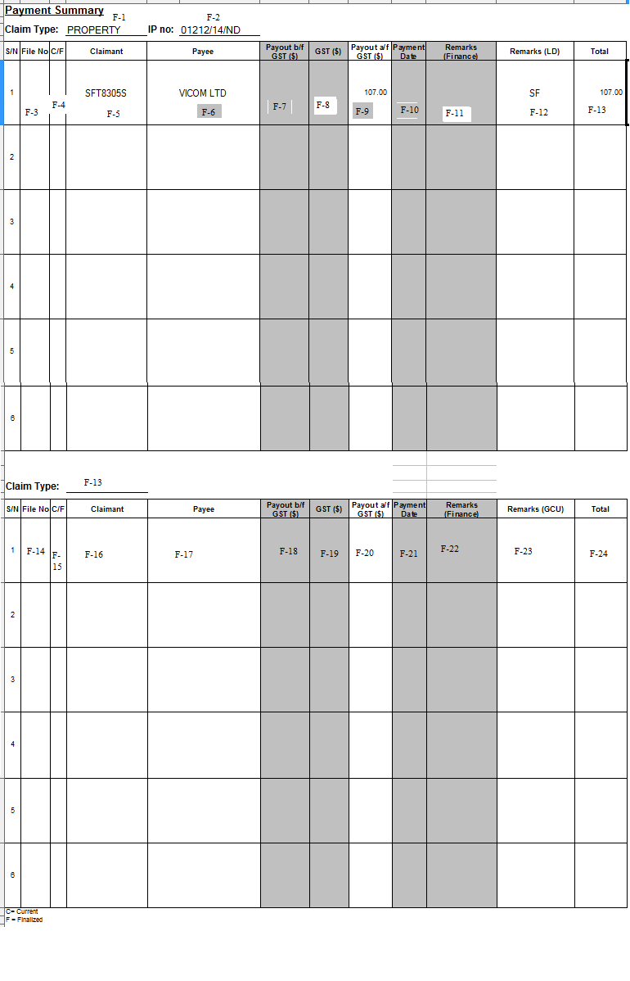

# Debit Note Requisition Form

|  |  |  |  |  |  |  |
| --- | --- | --- | --- | --- | --- | --- |
| **Form name** | Debit Note Requisition Form | | |  |  |  |
| Description |  | | |  | | |
| s.no. | Field number as per screen | Field names | screen Name | screen field name | EBIX Remarks | CDGI Remarks |
| 1 | F-1 | Date | Claims | Preview Documents | Date that Document is generated? |  |
| 2 | F-2 | IP no. | Accident | IP No. |  |  |
| 3 | F-3 | field not confirm | Accident | Vehicle No. |  |  |
| 4 | F-4 | field not confirm | Accident | Accident Date |  |  |
| 5 | F-5 | injured person name | Payment | Payee |  |  |
| 6 | F-6 | please refer attached screen shot | Unknown | Unknown | Payee's NRIC? |  |
| 7 | F-7 | company name | Insurance Policy | Insurer |  |  |
| 8 | F-8 | ref number | Unknown | Unknown |  |  |
| 9 | F-9 | Address 1 | Unknown | Unknown | Insurer's Address? |  |
| 10 | F-10 | Address 2 | Unknown | Unknown | Insurer's Address? |  |
| 11 | F-11 | s.no. | Unknown | Unknown | Is this from the Finance or Payment Tab? |  |
| 12 | F-12 | description | Unknown | Unknown | Is this from the Finance or Payment Tab? |  |
| 13 | F-13 | Amount % ( without GST) | Unknown | Unknown | Is this from the Finance or Payment Tab? |  |
| 14 | F-14 | GST % | Unknown | Unknown | Is this from the Finance or Payment Tab? |  |
| 15 | F-15 | SAP CODE | Unknown | Unknown | Is this from the Finance or Payment Tab? |  |
| 16 | F-16 | Cost center | Unknown | Unknown | Is this from the Finance or Payment Tab? |  |
| 17 | F-17 | total( Amount ($) ( without GST) | Unknown | Unknown | Is this from the Finance or Payment Tab? |  |
| 18 | F-18 | GST ( $) | Unknown | Unknown | Is this from the Finance or Payment Tab? |  |

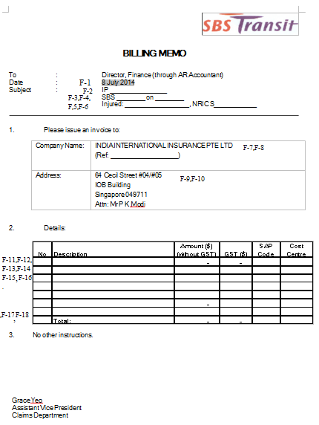

# Cheque Cancellation Or Reissue Memo With Field List

|  |  |  |  |  |  |  |
| --- | --- | --- | --- | --- | --- | --- |
| **Form name** | Cheque Cancellation Or Reissue Memo | | |  |  |  |
| Description |  | | |  | | |
| s.no. | Field number as per screen | Field names | screen Name | screen field name | EBIX Remarks | CDGI Remarks |
| 1 | F-1 | Please refer screen shot | Accident | IP No. / Claim No. |  |  |
| 2 | F-2 | field not confirm | Unknown | Unknown |  |  |
| 3 | F-3 | date | Claims | Preview Documents | Date that Document is generated? |  |
| 4 | F-4 | 1st party involved in accident | Accident | Vehicle No. |  |  |
| 5 | F-5 | 2nd party involved in accident | Unknown | Unknown | Another Vehicle No.? |  |
| 6 | F-6 | road name | Accident | Road Name |  |  |
| 7 | F-7 | accident date | Accident | Accident Date |  |  |
| 8 | F-8 | Please refer screen shot | Unknown | Unknown |  |  |
| 9 | F-9 | Please refer screen shot | Unknown | Unknown |  |  |
| 10 | F-10 | Please refer screen shot | Payment | Local Currency |  |  |
| 11 | F-11 | Please refer screen shot | Payment | Payee |  |  |
| 12 | F-12 | Please refer screen shot | Payment | Local Currency |  |  |
| 13 | F-13 | Please refer screen shot | Payment | Payee |  |  |

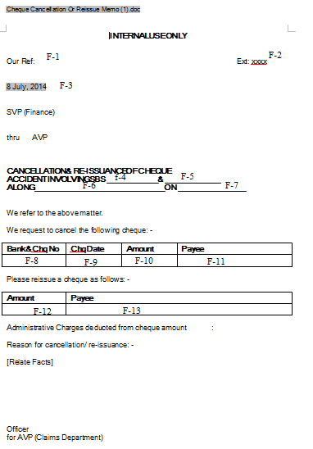

# Rule

|  |  |  |  |  |
| --- | --- | --- | --- | --- |
| **IF** | **Then** | **Else** | **And** | **Or** |
|  |  |  |  |  |
|  |  |  |  |  |

# Implementation

## Current Implementation

* Payment does not exist in application

## Targeted Implementation

* Payment Creation

# Change Required